Gentlemen’s Gallant Guards
Saber Order Form

About: The Order of the Steel Magnolias is extremely pleased to announce the formation of the Gallant Guard. Each of our Steel Magnolias certainly had one or more gallant men in their lives. Husband. Son. Father. Brother. Some came home to their beloved ladies, heartbreakingly, many did not.
Gentlemen who are approved for OSM membership will be known as the Gallant Guard, and will be honoring their Steel Magnolia great grandmothers and great aunts. The first 25 Gallant Guard members will also be known as the Honor Guard.

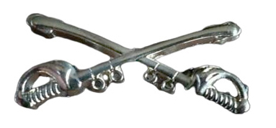
Silver Insignia Crossed Sabers
Measures 1.5 inches wide
May be worn on the OSM official insignia ribbon
$15.00 each ($5 shipping included)

Name: _____________________________________________Member # ___________
Address: _______________________________________________________________
Phone: ________________________ Email: ___________________________________

Mail order form and check (made payable to Order of the Steel Magnolias) to:

Leslie Kirk
324 Katie Lane
Titus, AL 36080-2810

